“Expert Cloud Consulting” -

AWS Serverless
21. March .2025
Version 1.0
─
Contributed by Tejal Kale
Approved by (In review)
Expert Cloud Consulting
Office #811, Gera Imperium Rise,
Hinjewadi Phase-II Rd, Pune, India – 411057

“Expert Cloud Consulting”
AWS Serverless

1.0 Contents
1.0 Contents 2
2.0 General Information: 3
2.1 Document / GitHub URL(s) 3
3.0 Prerequisites 4
4.0 Infrastructure Components 4
5.0 Installation and Configuration 5
5.1 Project Structure 5
5.2 DynamoDB Table Setup 5
5.3 Lambda Function Implementation 6
5.4 API Gateway Configuration 7
6.0 System Deployment 10
7.0 Testing and Validation 12
7.1 Form Submission Testing 12
7.2 API Testing 15
7.3 Dynamodb Data Verification 15
8.0 Security Configuration 16
8.1 API Key Management 16
8.2 CORS Configuration 16
8.2 IAM Permissions 16

2.0 General Information:

2.1 Document Purpose
This document details the implementation of a serverless contact form application using AWS cloud infrastructure. The solution integrates the following key AWS services:
- Amazon API Gateway – Manages and secures API endpoints.
- AWS Lambda – Handles backend processing and serves the frontend.
- Amazon DynamoDB – Provides persistent storage for form submissions.
- IAM (Identity and Access Management) – Controls permissions between services.

3.0 Prerequisites
Before proceeding with the implementation, ensure the following prerequisites are met:
- Active AWS Account with admin privileges
- AWS CLI installed and configured with appropriate permissions
- Basic knowledge of AWS services (Lambda, API Gateway, DynamoDB)
- Understanding of HTML, CSS, and JavaScript for frontend customization
- Python knowledge for Lambda function development
- Local development environment with code editor

5.0 Installation and Configuration

5.1 DynamoDB Table Setup

To set up a DynamoDB table, follow these steps:

Sign in to the AWS Management Console and navigate to Amazon DynamoDB.

Click on Create table and configure the settings as follows:

Table Name: dynamodb

Partition Key: email (String)

Table Settings: Use default settings

Tags: Add relevant tags for resource management

Click Create table and wait until the table status changes to Active.

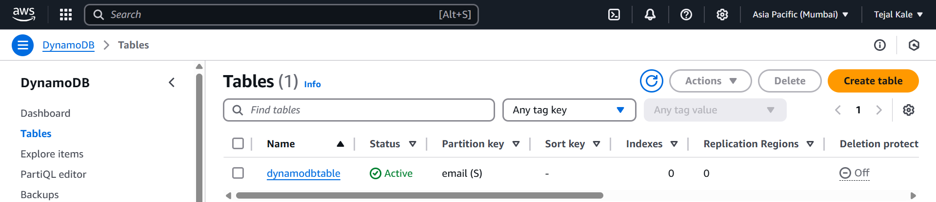

5.3 Lambda Function Implementation
Create a Lambda Function
Steps to Create the Function:
Go to AWS Lambda Console → Click Create Function.
- Select "Author from scratch".
- Enter a Function Name (e.g., Serverless-App).
- Select a Runtime (e.g., Python 3.9).
- Choose Existing Role → Select LambdaExecutionRole.
- Click Create function.

- Now Click on Upload from .zip file and add the Html and python files.
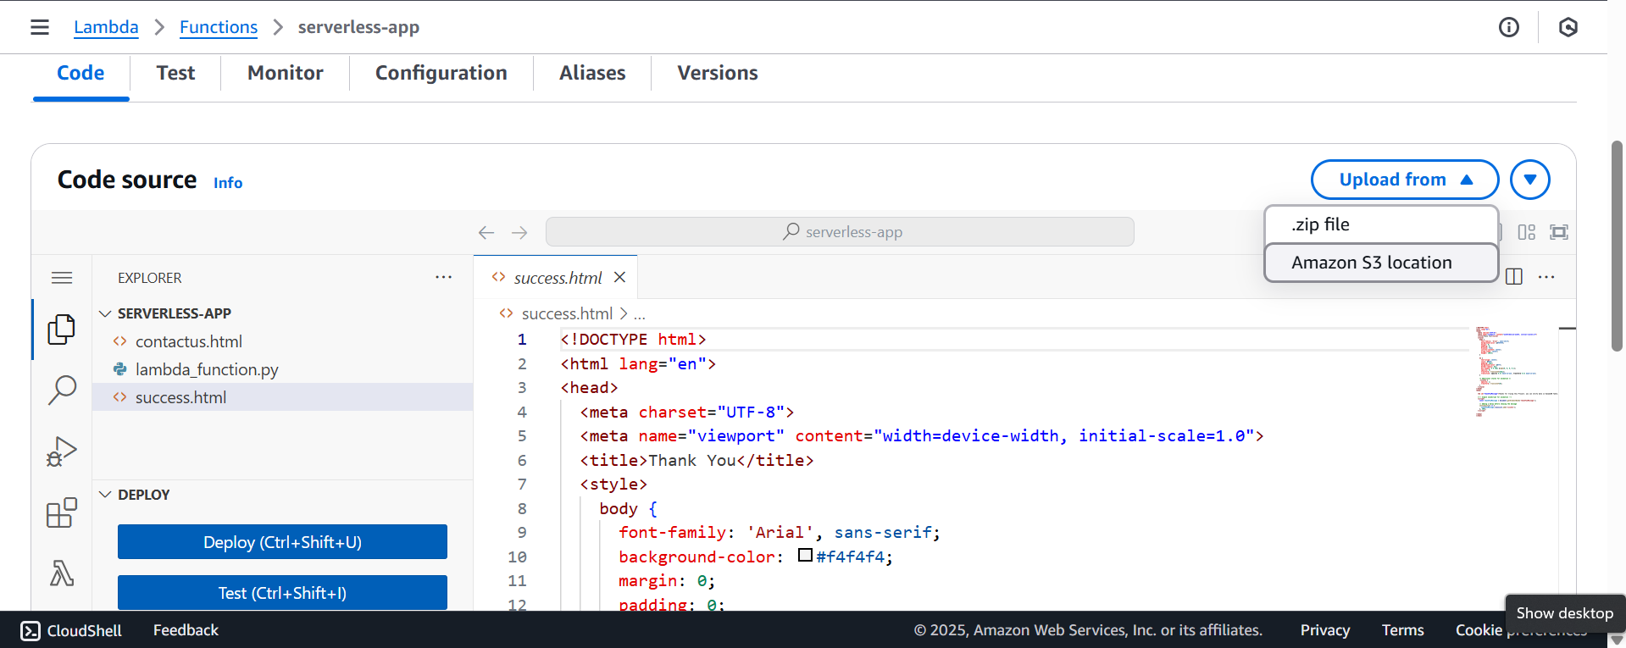

5.4 API Gateway Configuration

Navigate to API Gateway in the AWS Management Console

Click "Create API" and select "REST API"

Set the API name to "contact-form-api" and choose "Regional" endpoint type

Click "Create API"

Create a new resource by clicking "Create Resource"

Add methods to the resource:

Click "Create Method"
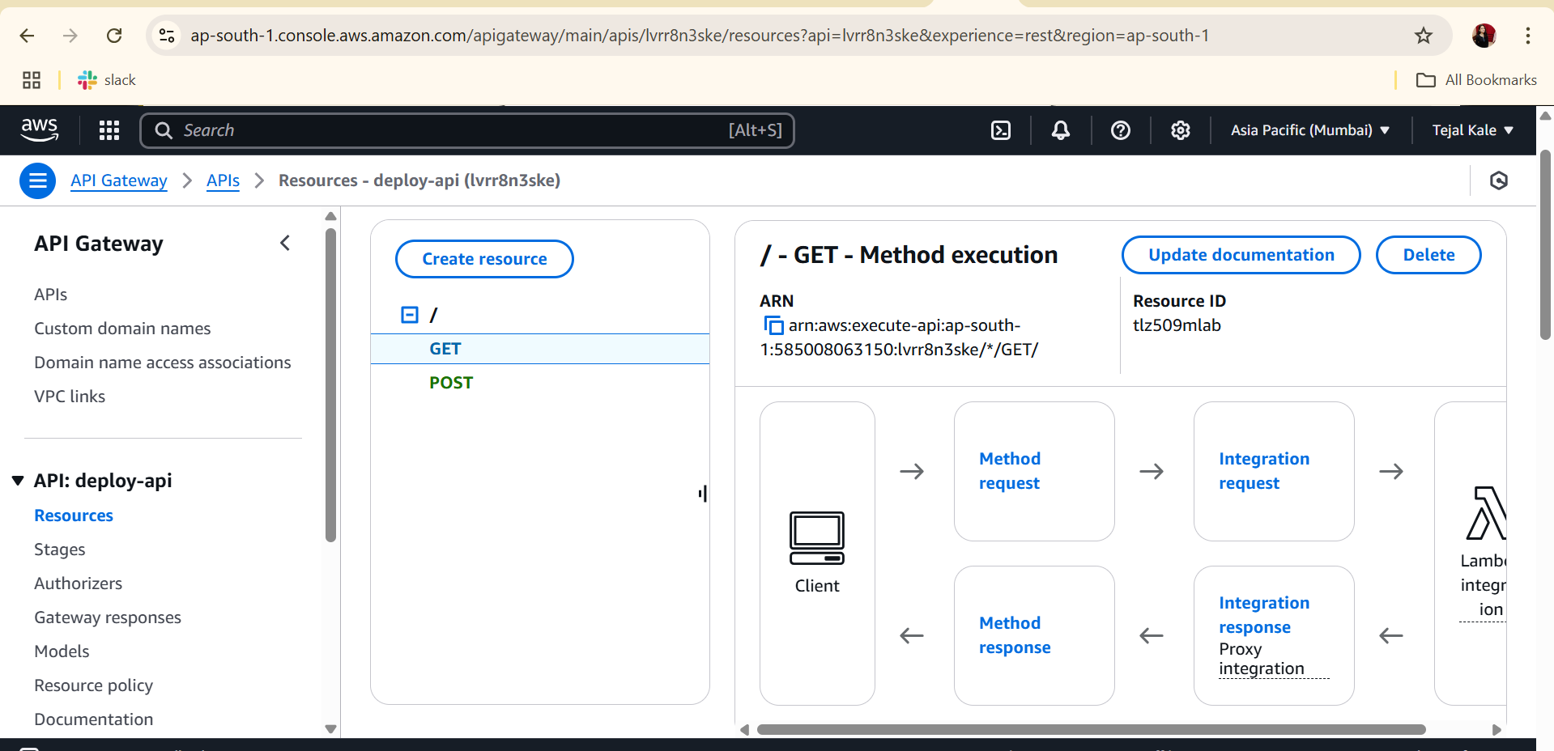
- Select "GET" from the dropdown and click the checkmark
- Configure the GET method:
  - Integration type: Lambda Function
  - Lambda Function: contactUS
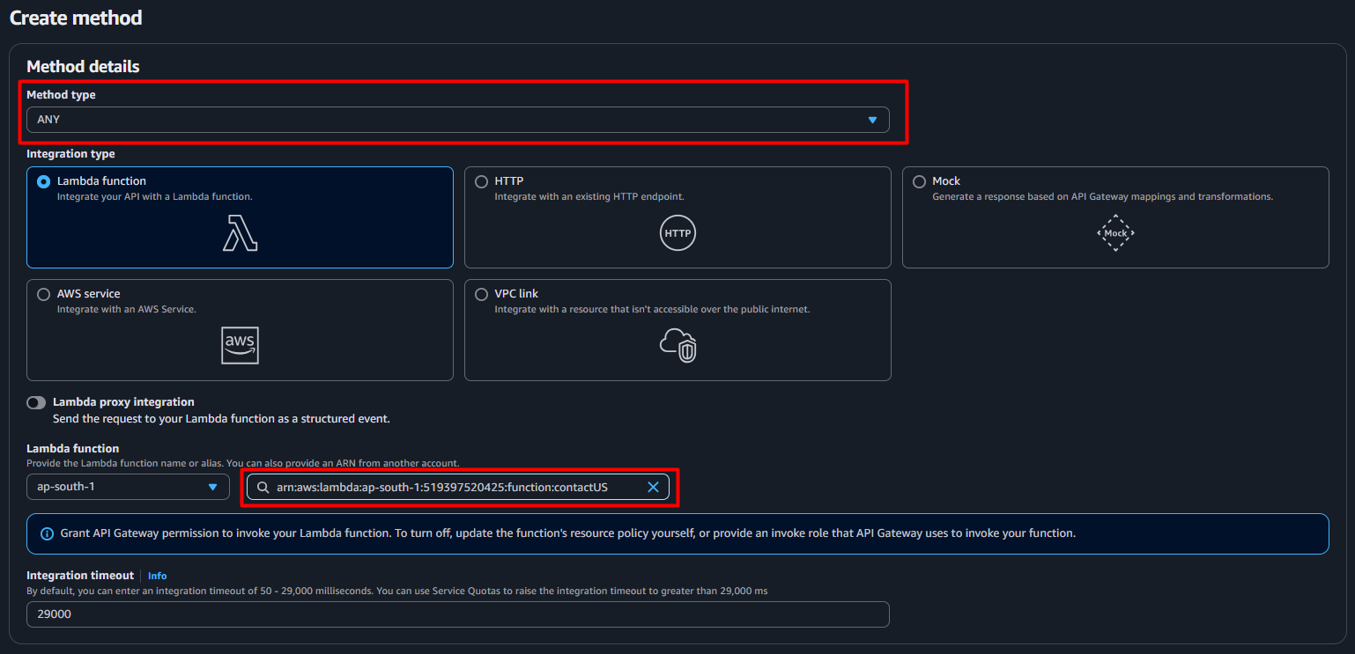
  - Use Default Timeout: Checked
  - API Key Required: NO
  - Click "Save"
- Repeat for POST with the same Lambda function
Deploy the API:
- Click "Deploy API"
- Deployment stage: [New Stage]
- Stage name: "dev"
- Stage description: "Development environment"
- Click "Deploy"
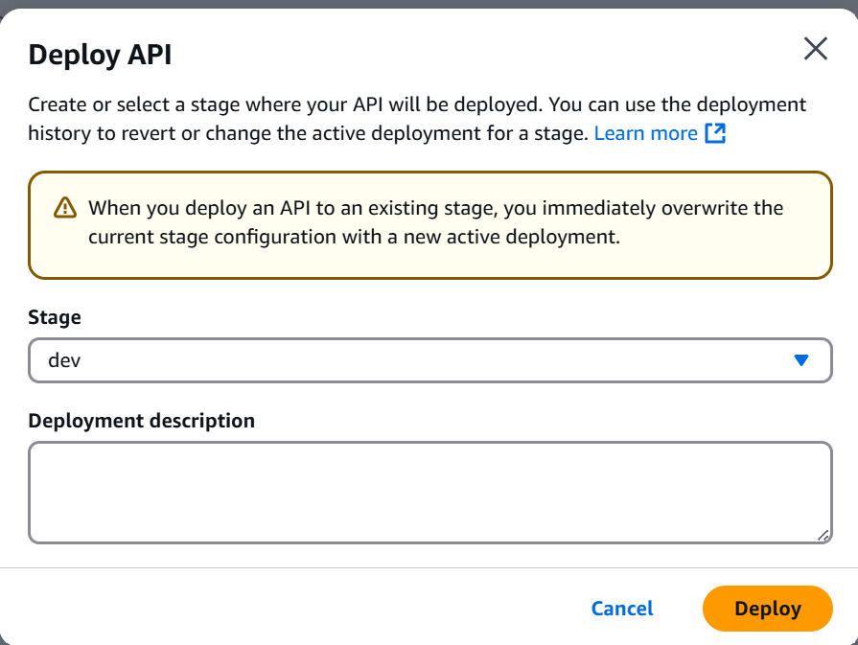
• Create an API Key:
- In the left navigation panel, click "API Keys"
- Click "Create API Key"
- Name: "Demoapi"
- Click "Save"
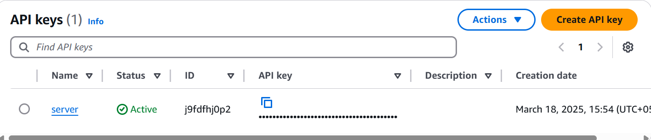
Create a Usage Plan:
- In the left navigation panel, click "Usage Plans"
- Click "Create Usage Plan"
- Name: "contact-form-plan"
- Enable throttling and quota as needed
- Click "Next"
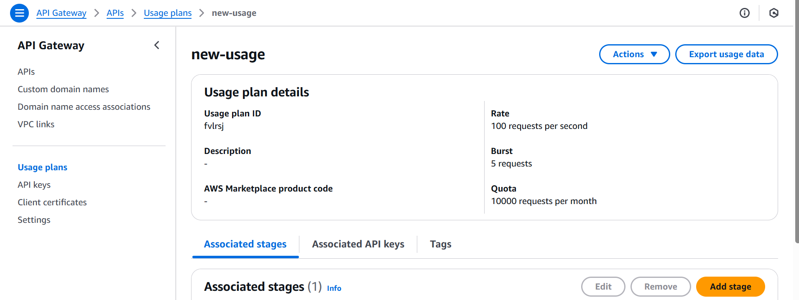
- Add API Stage:
  - API: Demo-api
  - Stage: dev
  - Click "Next"
- Add API Key to Usage Plan:
  - Select the "pre-plan"
  - Click "Done"
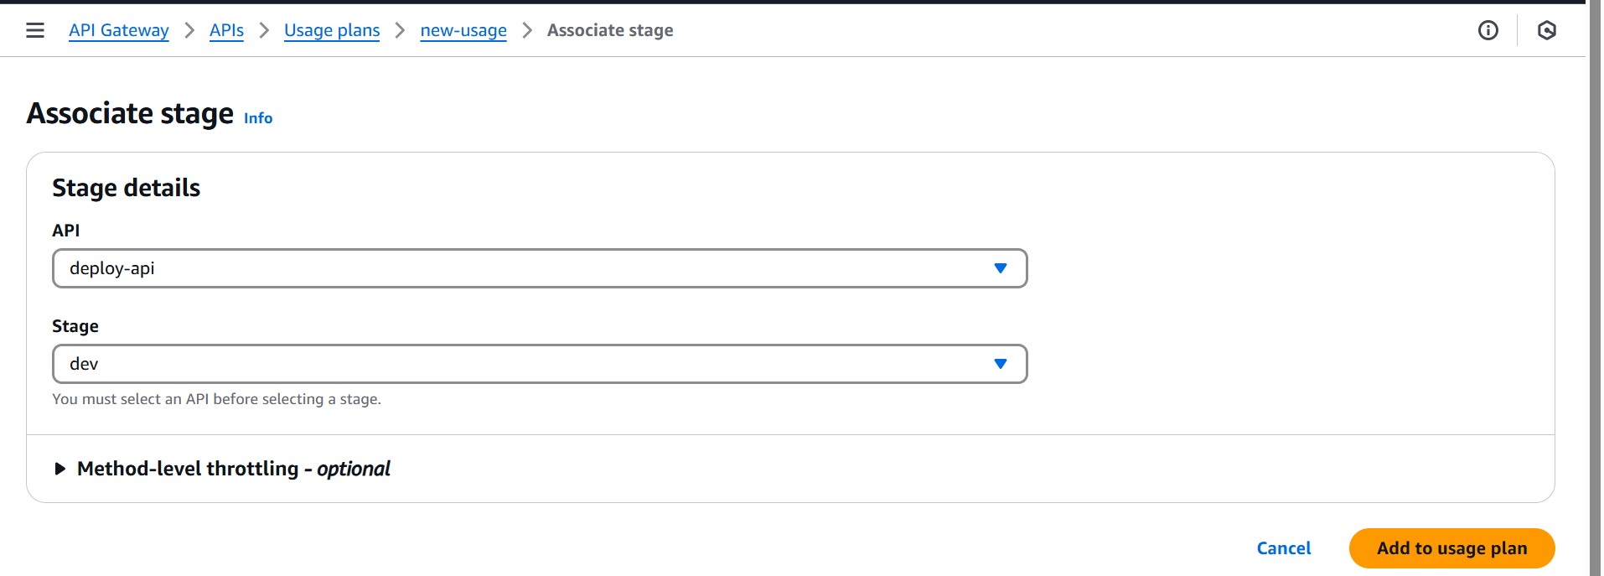
Note the API Gateway URL and API Key for frontend configuration

6.0 System Deployment

Update the Lambda function with the HTML templates:
- Upload the contactus.html and success.html files via the Lambda console
- Or compress and upload the function code as a ZIP file
Configure the environment variables for the Lambda function:
- Set DYNAMODB_TABLE to "dynamodb"
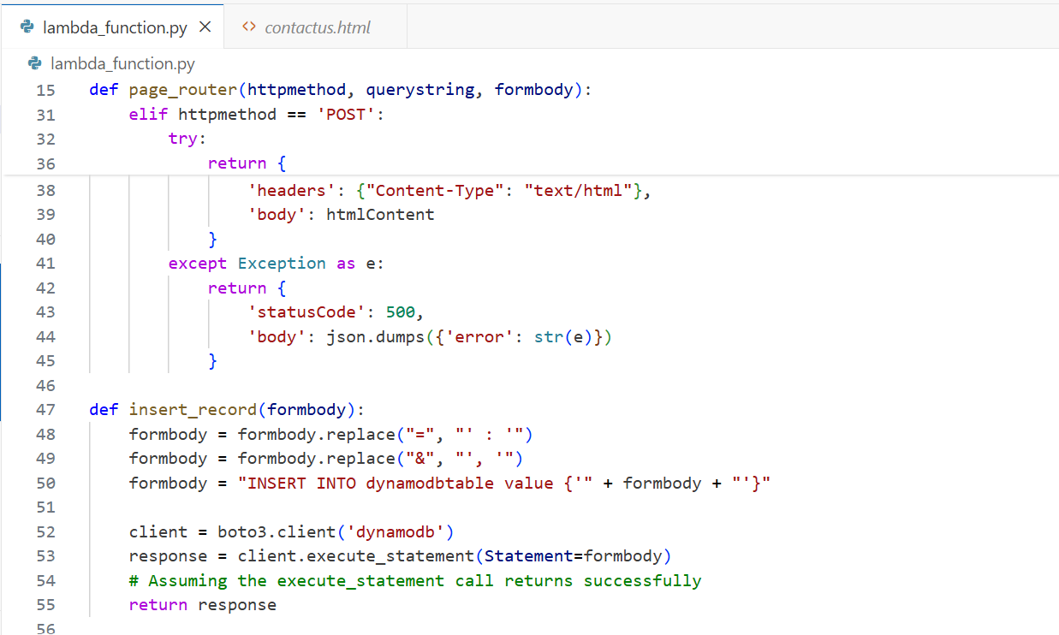
Update the IAM role for Lambda to allow Dynamodb access:
Navigate to the IAM console
Find the role created for your Lambda function
Attach the "AmazonDynamoDBFullAccess" policy (or create a custom policy with more granular permissions)
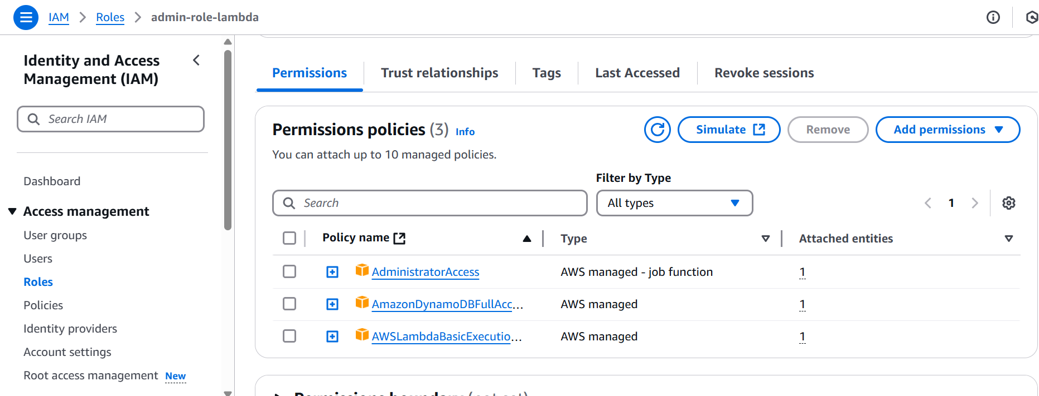
Deploy or redeploy your API to make changes effective

7.0 Testing and Validation

7.1 Form Submission Testing
Access the contact form through your API Gateway URL
Fill out the form with test data
submit the form and verify that:
- Form validation works correctly
- The loading indicator appears during submission
- The success message displays after submission
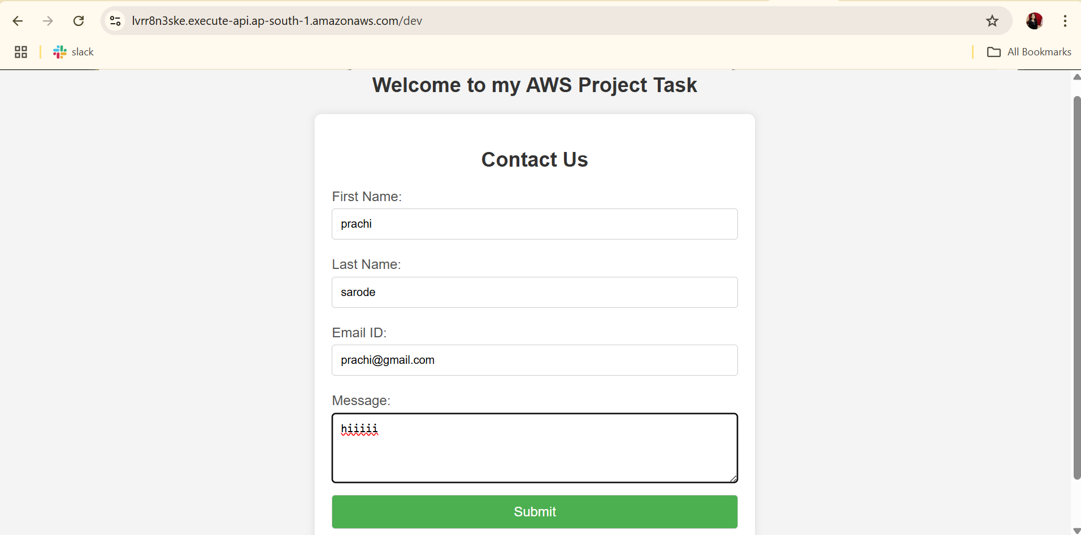
- Redirection to the success page works
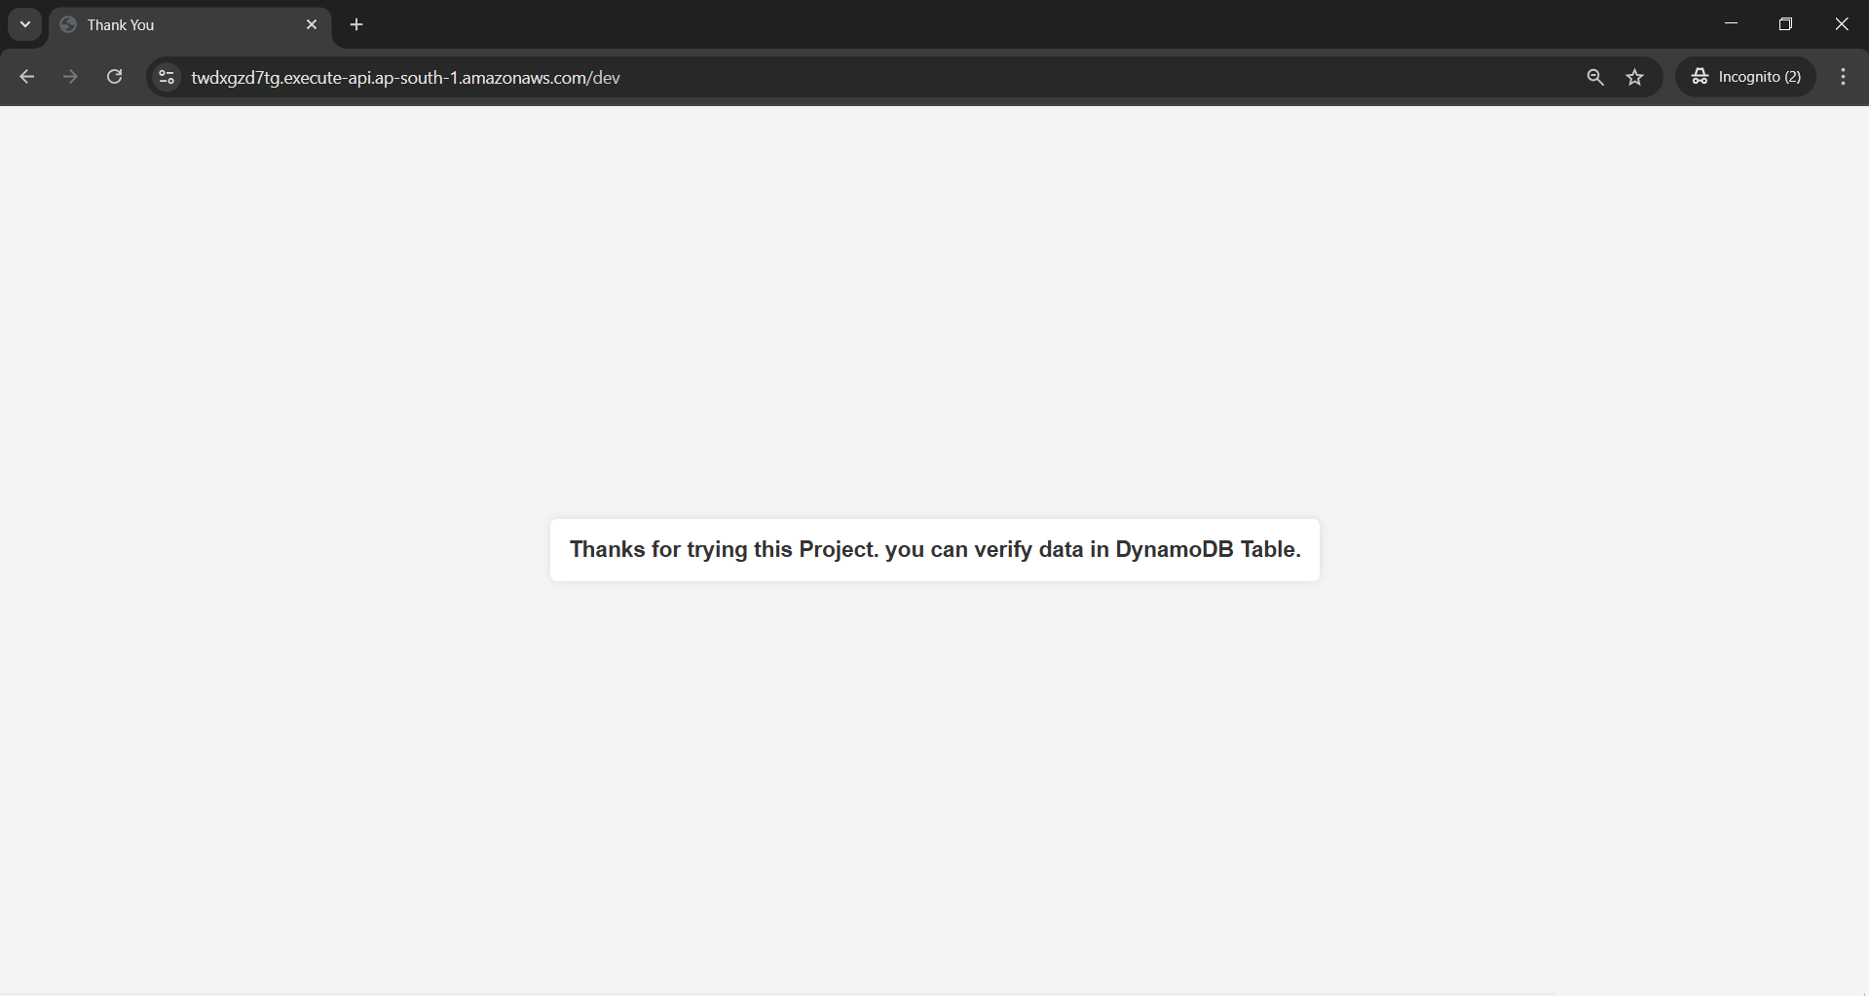
- Check the DynamoDB table.
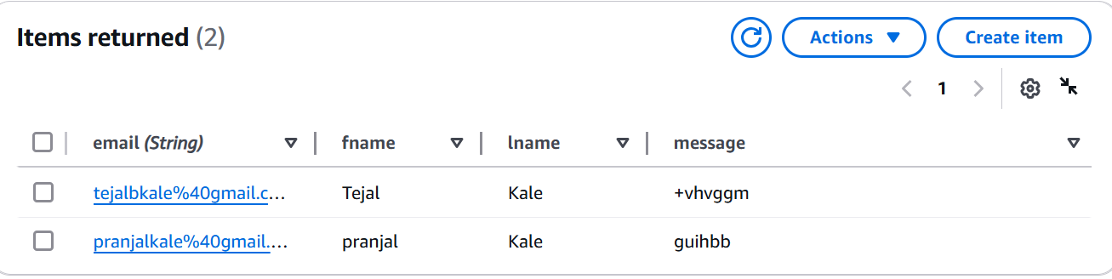
- Now Edit the post method in api gateway to secure it.
- Enable API key and IAM role required in post method.
- Redeploy the Api-gateway.
- After enabling the api-key and IAM role for authorization. The Post method will not work.
- Error “Forbidden” which would be Access key and secret access key of the IAM role.
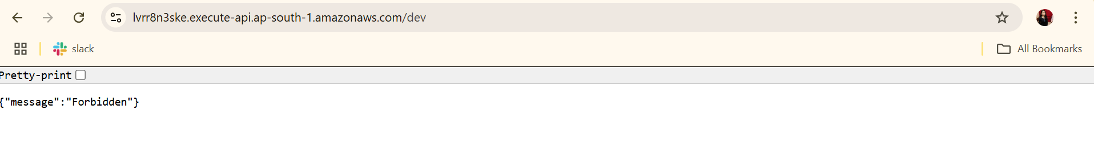

- Api-key required Error “Forbidden”. This means the Api key this required for authorization.
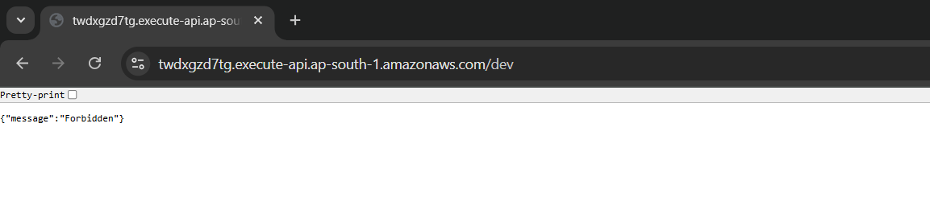Note: API key best practice is not to use while client authorization. Mainly the api-key is use for developer Authorization, Monitor API Usage, Troubleshoot API request and identify projects.
- To test the api with api-key and and IAM role Authorization, Use postman to test api with api-key and IAM roles.
- Now I have secure Get method and redeploy the API.
- Add the AWS signature.
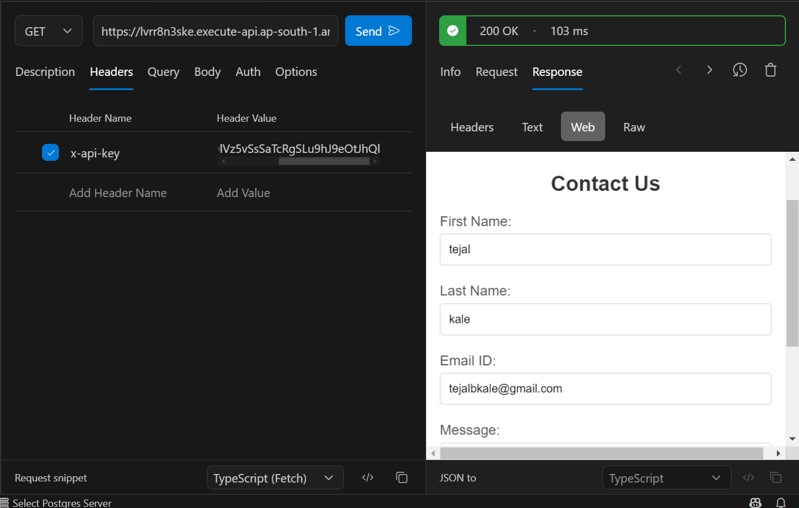

7.2 API Testing
• Test the GET endpoint:
- Using a browser, navigate to your API Gateway URL
- Verify that the contact form loads correctly
• Test the POST endpoint:
- Using a tool like Postman or curl
- Send a POST request with valid JSON data
- Include the x-api-key header with your API key
- Verify successful response (status code 200)
• Test error handling:
- Submit invalid data (missing required fields)
- Verify appropriate error responses

7.3 Dynamodb Data Verification
• Navigate to the Dynamodb console
• Open the "Users" table
• Verify that form submissions are being stored correctly
• Check that all fields are present and formatted correctly

8.0 Security Configuration

8.1 API Key Management
The API is secured using API keys to restrict access to authorized users. Follow these steps to manage API keys:
- Generate API Key:
  - Navigate to API Gateway in the AWS Console.
  - Select the contact-form-api.
  - Click on API Keys in the left navigation panel.
  - Click Create API Key and enter a descriptive name.
  - Click Save and copy the generated API Key.
- Associate API Key with Usage Plan:
  - Navigate to Usage Plans.
  - Select contact-form-plan.
  - Click API Keys and select the newly created API Key.
  - Click Add API Key to Usage Plan.
- Enable API Key Requirement for Methods:
  - Open the API Gateway.
  - Select Resources and choose the contact resource.
  - Click Method Request.
  - Set API Key Required to true.
  - Deploy the API to apply changes.
- Distribute API Key Securely:
  - Ensure API keys are not hardcoded in frontend code.
  - Store API keys securely using AWS Secrets Manager or environment variables.
  - Rotate API keys periodically for security.

8.2 CORS Configuration
To enable CORS (Cross-Origin Resource Sharing) for API Gateway:
- Navigate to API Gateway and select contact-form-api.
- Click on the contact resource and select OPTIONS.
- In Method Response, add the following headers:
  - Access-Control-Allow-Origin: *
  - Access-Control-Allow-Methods: POST, GET, OPTIONS
  - Access-Control-Allow-Headers: Content-Type, x-api-key
- Click Save, then Deploy API to apply changes.
- Test CORS settings using browser developer tools or Postman.

8.2 IAM Permissions
IAM roles ensure secure interactions between AWS services. Configure IAM permissions as follows:
- Lambda Execution Role:
  - Navigate to IAM Console.
  - Create a new role with AWS Lambda as the trusted entity.
  - Attach the AmazonDynamoDBFullAccess policy.
  - Attach the AWSLambdaBasicExecutionRole policy for logging.
  - Save the role and attach it to the Lambda function.
- API Gateway Execution Role:
  - Create a new role with API Gateway as the trusted entity.
  - Attach AmazonAPIGatewayInvokeFullAccess.
  - Assign the role to API Gateway.

